A superb intro by former thesis student Anna Cole (class of 2025)
Introduction
Olfaction Overview
One of the driving questions of sensory neuroscience is how stimulus features are mapped onto patterns of neural activity. In the visual and auditory systems, this basic mapping is well understood. With vision, maps of the visual light spectrum capture how different wavelengths of light are encoded as color. In the auditory system, the frequency of sound waves have been mapped to humans’ perception of pitch. However, relatively little is known about how a scent’s chemical structure relates to how it is perceived, or how it is represented in the brain.
This is especially surprising given the olfactory system’s ecological relevance–2% of protein-coding genes in the human genome code for olfactory receptors (Barnes et al., 2020). The olfactory system is used to perceive food in an environment, determine a food’s nutritional value, and regulate appetite (Boesveldt & Parma, 2021). Additionally, because the hippocampus and amygdala have rich interconnections with the primary olfactory cortex, odor perception is strongly linked with memory and emotion (Herz, 2016). The scent of sweat has also been shown to play a role in newborn attachment, emotional intelligence, and sexual compatibility (Boesveldt & Parma, 2021).
In addition to ecological significance, the question of olfaction also has economic significance. The production of scent forms the basis of several industries–most notably the perfume/fragrance industry, which was valued at 48.05 billion total revenue in 2023 (Fortune Business Insights, 2024). Artificial scent detection could also have implications for medical diagnosis, emergency prevention, pharmaceuticals, and food production, to name a few. Understanding the link between a scent’s chemical structure and how the olfactory system encodes and represents it would be an important discovery for both basic and applied science.
While it is clear that olfactory mapping is a critical question, finding a concrete answer has been elusive. Odor molecules exhibit a vast array of physical, chemical, and structural properties that could influence how the molecule interacts with olfactory receptors, creating a vast and complex feature space (Gerkin, 2021). Olfactory receptors are similarly complex; there exist several hundred different G-protein-coupled receptors (GPCRs) in the sensory neurons of the olfactory epithelium. Each receptor can participate in the detection of multiple odorants, and each odorant can activate multiple receptors, leading to a complex coding system (Malnic et al., 1991).
Further complicating the question is the fact that molecules with similar structures can produce wildly different percepts, and vice versa. This phenomenon is well demonstrated by Sell’s (2006) triplet: an example of two molecules that differ only with a double bond, yet one is odorless and one has the descriptors: muguet, fresh, floral, and sweet. Conversely, there is a molecule that is not at all structurally similar to the first two, but has almost the exact same perceptual descriptors: muguet, fresh, floral, and rosy. This indicates that we are unlikely to find simple rules in which salient perceptual categories correspond to simple molecular attributes.
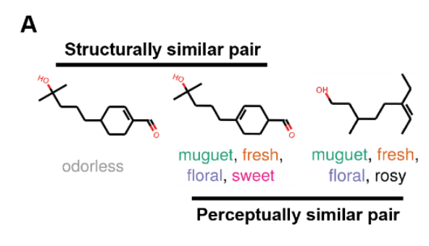
Figure 1: Sell’s (2007) triplet (as found in Lee et al., 2023).

Machine Learning in Olfaction
Given the complexity and high dimensionality of olfactory perception, traditional approaches have struggled to establish clear rules linking molecular structure to odor perception. The nonlinearity of olfactory coding, the combinatorial nature of receptor activation, and the variability in human perception all suggest that a straightforward mapping does not exist. However, this is precisely the kind of challenge where machine learning excels; it is optimized for finding complex mappings from a feature space (chemicals) to a target space (percepts/odor maps). By leveraging its ability to identify complex, high-dimensional patterns, machine learning could offer new insights into how chemical features translate into olfactory perception.
Significant strides have been made in the field of olfactory neuroscience over the past decade with the use of machine learning and large datasets. In 2015, Keller et al. (2017) organized the DREAM Olfaction Prediction Challenge–a competition to build computational models that could predict a molecule’s odor percept. 19 percept descriptors were given, including “sweet”, “burnt”, and “garlic”, as well as 476 molecules which had been determined by humans to hold these descriptors. The winning model was able to accurately predict an odor’s intensity, its pleasantness, and 8 of the 19 descriptors–(“burnt”, “fish”, “flower”, “fruit”, “garlic”, “sour”, “spices”, and “sweet”) (Keller et al., 2017).
Kowalewski et al. (2021) extended this work using several different chemical-descriptor datasets, such as the Dravnieks Atlas (1985) and Keller and Vosshall’s (2016) dataset. They found that a model trained on one dataset could predict equally well the descriptor ratings given by another dataset. This suggests that their model is able to predict something foundational about olfactory perception rather than memorize a specific dataset (Gerkin, 2021).
Similarly, Lee et al. (2023) were able to correlate molecules’ chemical properties with their odor percepts using a message passing neural network (MPNN) that analyzed a dataset of ~5000 molecules’ structural and perceptual properties. They were able to construct a principal odor network (POM) that could predict olfactory percepts more reliably than the median human panelist (Lee et al., 2023).
These advances in machine learning demonstrate that perceptual labels can, to some degree, be predicted from chemical structure. However, these models sidestep a key question in sensory neuroscience: how is this information represented in the brain itself? For machine learning to truly "crack the odor code," it must ultimately help bridge the gap between stimulus features and neural representations.

Olfactory System Overview
To approach the question of how stimuli are processed and perceived in the olfactory system, it is first necessary to address the organization of the olfactory system. As olfactory stimuli enter the nose, they bind to odorant receptors. These odorant receptors, which are membrane-spanning G protein-coupled receptors, are expressed on the surface of olfactory sensory neurons located in the olfactory epithelium (Buck and Axel, 1991). Thousands of olfactory sensory neurons that express the same olfactory receptor gene then project centrally, where their axon terminals converge into clusters called glomeruli. Post synaptically, each glomerulus is connected to the dendrites of ~50 neurons in the olfactory bulb. This creates a chemotopic map (Figure 2), wherein each odor activates a distinct spatial pattern across the bulb (Mombaerts et al., 1996). The olfactory bulb then relays this spatial activation pattern via mitral cells, the principal output neurons of the bulb. Each mitral cell receives input from a single glomerulus and transmits this information to downstream brain regions for further perception (Schoppa & Westbrook, 2001).
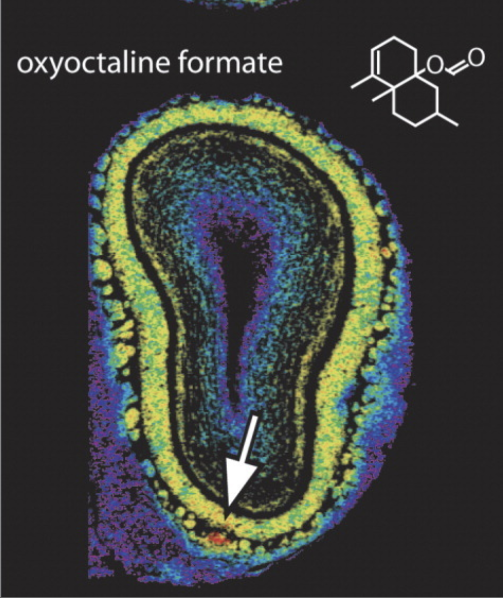
Figure 2: An example of a glomerular map in a rat’s olfactory bulb after smelling oxyoctaline formate (Johnson & Leon, 2007).

Olfactory Bulb Spatial Imaging Methods
The olfactory bulb’s unique position, one synapse removed from the sensory periphery, makes it an ideal target for observing olfactory activity before it moves to higher-level processing in other brain areas (Falasconi et al., 2012). The spatial encoding of the olfactory bulb has been well studied. Early attempts at understanding the olfactory system’s method of discriminating between stimuli, such as Yokoi et al. (1996), made use of methods such as single unit cell recording to understand how synaptic regulation occurs in the olfactory bulb. They noted that individual mitral cells will exhibit excitatory responses to a given molecule and inhibitory responses to molecules with similar structures, indicating a strong level of discrimination. However, without the use of olfactory imaging methods, they had only a limited portrait of how activity was distributed across space. The first imaging study of the rat olfactory bulb was conducted by Rubin & Katz (1999) using intrinsic optical imaging. This method takes advantage of the fact that oxygenated and deoxygenated forms of hemoglobin absorb different amounts of red light. Because blood is rapidly directed to active brain areas, local changes in light absorption can be used as a proxy for neural activity. In this technique, the olfactory bulb is illuminated with red light, and a video camera records changes in reflectance as a proxy for underlying neuronal activation. This study confirmed the chemotopic mapping theory, finding that different odorants produce reliable and distinguishable patterns of glomerular activation (Rubin & Katz, 1999). Meister and Bonhoeffer (2001) extended this technique, using intrinsic optical imaging to test Yokoi et al. (1995)’s theory that the excitatory range of mitral cells is mediated by the glomerulus primarily attached to that mitral cell. They observed that glomeruli with similar tuning properties tend to cluster together, supporting the idea that the small excitatory range of mitral cells is meant to facilitate contrast enhancement between similar odorants (Meister & Bonhoeffer, 2001).
In an attempt to understand the response properties of specific glomeruli, Soucy et al. (2009) used a combination of intrinsic optical imaging and synaptopHluorin (SpH). SpH is a pH-sensitive fluorescent protein that fuses to synaptic vesicle proteins, enabling fluorescent imaging of synaptic activity in the olfactory bulb. They were able to tag ~30 specific glomeruli in mice based on their sensitivity patterns to given stimuli. They then compared the tagged glomeruli to the mouse’s other olfactory bulb, determining that the matching glomeruli were systematically displaced in the other olfactory bulb in a way that matched the olfactory bulbs of other mice. They also compared the locations of the tagged glomeruli to the rat olfactory bulb, noticing that many glomeruli responded to the same stimulus patterns in both species, and that these matching glomeruli occupied similar positions in the mouse and rat olfactory bulb. This suggests that glomeruli have a deliberate organization in the olfactory bulb that is consistent across species (Soucy et al., 2009).
12 years later, Burton et al. (2021) attempted to once again define glomeruli by the odorants that they are most sensitive to. They used more advanced techniques–high-throughput odorant delivery and a combination of widefield and two-photon imaging–in order to create clearer, more high-resolution images of olfactory responses in mice. They noted that many glomeruli showed a narrow response range (~25% only responded to one odorant), a finding in line with Meister & Bonhoeffer’s (2001) observations and Yokoi et al. (1995)’s predictions. However, they found many other glomeruli that are sensitive to distinct odorants with common structural features, and noted that these tended to appear near one another in spatial clusters (Burton et al., 2021).

Spatial vs. Temporal Encoding of Olfactory Activity
While the olfactory bulb’s spatial encoding has been proven, there are two main theories about how olfactory activity is then translated to higher-level perception. The spatial theory states that perception is driven by different spatial activity patterns in the olfactory bulb, while the temporal theory states that perception is due to the timing and evolution of neuronal firing in the olfactory bulb. Chong et al. (2020) tested both of these theories in the mouse olfactory bulb. They used optogenetics to activate specific glomerular patterns in mice, and trained the mice to respond when a target glomerular pattern was activated. They then systematically altered the glomerular patterns, noting which changes were enough for the mouse to perceive the scent differently. Their results suggest a linear readout of spatial glomerular patterns, or the idea that similar patterns will generate odors that are perceptually similar. They also tested the temporal theory of odor encoding, which suggests that perceptual responses are based on the timing and evolution of neuronal firing in the olfactory bulb. They noted a primacy effect, where glomeruli that had been activated earlier in the pattern-perceiving process had larger effects on the mices’ responses, but noted that this may play more of a role in distinguishing between certain concentrations, rather than determining olfactory perception entirely.
Johnson and Leon (2007) Dataset/Clustering Analyses
Despite the compelling evidence for chemotopic mapping in the olfactory bulb, a major challenge remains: how to systematically analyze and interpret these complex spatial patterns of activity. Crucially, we also need to uncover the underlying structure of the olfactory bulb’s mapping. A map of an olfactory bulb can be considered high-dimensional, with each pixel reflecting activation across many glomeruli. The manifold hypothesis proposes that many high-dimensional spaces, such as the olfactory bulb, can actually be condensed and described by a smaller number of dimensions (Fefferman et al., 2016). It is possible that the patterns in the olfactory bulb can be described by a lower-dimensional manifold: a latent space that reflects the true organizational principles of olfactory coding. Identifying such a manifold would allow us to define a meaningful coordinate system over odor representations, making it possible to compare maps, predict responses to novel stimuli, and probe how chemical features are encoded spatially in the olfactory bulb. In order to identify this manifold, though, we need both a large and standardized dataset, as well as computational methods capable of capturing the subtle, nonlinear relationships between chemical structure and spatial representation.
This is precisely what makes the work of Johnson and Leon so appealing. Over the span of several years, they developed a robust and reproducible method for imaging glomerular activity in the rat olfactory bulb using 2-deoxyglucose (2-DG) autoradiography: a technique that captures metabolic activity across the glomerular layer in response to odor stimulation. Their work resulted in a comprehensive, standardized dataset of ~300 stimulus-evoked glomerular maps, each with precisely measured spatial patterns. Additionally, each map is spatially registered on the same coordinate frame, allowing us to package it as a tensor in Python and perform machine learning on it.
Notably, each stimulus in this dataset triggered a different glomerular activity pattern, and different animals demonstrated similar patterns of activity in response to the same stimulus. This indicates that glomerular activity is triggered by a chemical’s molecular features (Johnson et al., 1999). Johnson and Leon have observed several clustering patterns within subsets of their larger dataset. Mapping a series of aliphatic acids with similar structures produced patterns scattered around similar clusters in the olfactory bulb, with the clusters increasing in size and activity as the carbon chain length increased (Johnson et al., 1999). This trend was also observed in a group of isoamyl esters, ethyl esters, butyrates, and acetates, all of whom possess the same base and different combinations of two functional groups. The cluster size, complexity, and amount of 2-DG uptake all increased as the molecule increased in complexity (Johnson et al., 1998).
Johnson and Leon (2007) also noted that clusters of activity in the lateral portion of the olfactory bulb often corresponded with clusters in the medial portion. They proposed a model of the olfactory bulb where glomerular responses are chemotopically organized. Odorant molecules that share specific molecular features—such as functional groups, hydrocarbon structure elements, or general properties like water solubility—tend to activate overlapping but unique sets of glomeruli. In their module (Figure 1), the following clusters were identified: Aa—carboxylic acids, methyl and ethyl esters; Bb—primary alcohols, aldehydes, phenols; Cc—aromatics with O groups, high concentration of ketones; Dd—aromatic hydrocarbons; Ee—aliphatic esters; Ff—highly water-soluble compounds; Gg—septal organ projection, broadly responsive; Ii—methyl-substituted bicyclic compounds; H—aliphatic hydrocarbon chains.
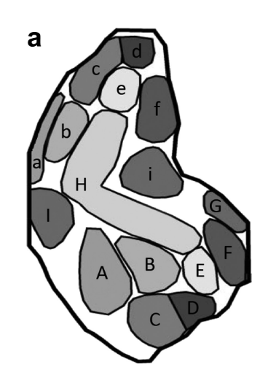
Figure 1: Johnson and Leon’s (2007) glomerular clusters, which were defined by comparing overlapping patterns to define unique clusters. Each time a cluster unique to an odorant or concentration was detected in the lateral part of the bulb (labeled with lowercase letters), another cluster was detected in the medial part (labeled with uppercase letters). The clusters correspond to these stimulus features: Aa—carboxylic acids, methyl and ethyl esters; Bb—primary alcohols, aldehydes, phenols; Cc—aromatics with O groups, high concentration of ketones; Dd—aromatic hydrocarbons; Ee—aliphatic esters; Ff—highly water-soluble compounds; Gg—septal organ projection, broadly responsive; Ii—methyl-substituted bicyclic compounds; H—aliphatic hydrocarbon chains.

As noted by Falasconi et al. (2012), this cluster mapping is limited by the assumption that visual clusters exist to begin with. Additionally, the mappings were done on data subsets rather than every stimulus map in Johnson and Leon’s (2007) extensive dataset, meaning that dissimilar odorants may share similar clustering patterns that were not accounted for. To this end, Falasconi et al. (2012) conducted a computational clustering study of the entire dataset. They conducted a fuzzy c-means clustering analysis, finding that the maps separated most efficiently into 3 separate clusters (Figure 2). They then statistically correlated the clusters with 21 hand-chosen features based on their prevalence in the dataset. Within the overlaps with Johnson and Leon’s (2007) mapping, they noticed some similarities, such as significantly more esters, aromatic esters, and aliphatic esters in cluster 3b, which overlaps with Johnson and Leon’s (2007) ester (Ee) cluster. However, the cluster number and exact boundaries of Johnson and Leon’s (2007) mapping and Falasconi et al.’s (2012) mapping are not perfectly aligned.
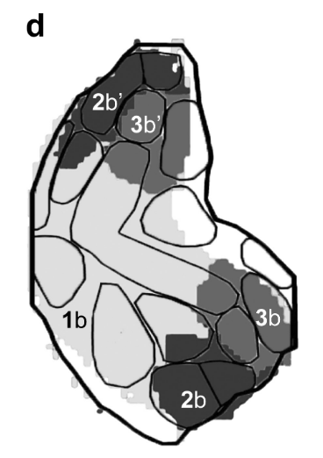
Figure 2: Falasconi et al.’s (2012) clustering analysis, shown overlaid with Johnson and Leon’s (2007) clustering model.

These differences suggest that while some patterns exist in the Johnson and Leon (2007) dataset, a precise mapping has yet to be identified. This may be partly due to the hand-mapping method used by Johnson and Leon (2007) or the limited set of 21 features examined by Falasconi et al. (2012).

Principal Component Analysis
Dimensionality reduction techniques may offer a more systematic way to uncover latent structure in olfactory spatial representations, leading us to a manifold that could describe the olfactory bulb’s topography. One such technique is principal component analysis (PCA), which identifies the directions of greatest variance in high-dimensional data and projects the data onto a lower-dimensional space (Greenacre et al., 2022). In the context of the olfactory bulb, PCA may help reduce noise and highlight the most salient spatial patterns of neural activity across stimuli. This leads to our first research question: Can we use principal component analysis (PCA) to better understand the olfactory bulb’s topographical organization? We hypothesize that the key principal components will reveal distinct spatial patterns of neural activity in the olfactory bulb.

Convolutional Autoencoder
While principal component analysis works well for identifying features with the highest variance, it is limited by the fact that it is a linear method. This means that it may miss more complex, nonlinear relationships in the data–relationships that are likely to exist in neural systems like the olfactory bulb, where activity patterns emerge from intricate, multidimensional interactions. To address this limitation, we can turn to convolutional autoencoders as another way of spatially analyzing the Johnson and Leon (2007) dataset. Convolutional autoencoders are a type of unsupervised neural network model that is designed to learn efficient, compressed representations of data, then effectively reconstruct that data. Unlike PCA, autoencoders can learn nonlinear transformations, allowing them to capture more complex structure in the data (Zhang, 2018). Autoencoders consist of two main components: an encoder, which maps the input into a compressed latent space, and a decoder, which attempts to reconstruct the original input from that compressed representation. Once trained, such networks often find efficient, lower-dimensional representations of the original dataset, and the data can be described by a new coordinate system defined by features of the latent space (the bottleneck layer). Autoencoders have been widely used in domains such as image compression, denoising, and anomaly detection (Goodfellow et al., 2016). They are particularly well-suited for analyzing high-dimensional image-like data, such as Johnson and Leon’s (2007) olfactory heatmaps. This brings us to our second research question: Can we train a convolutional autoencoder to encode heatmaps into a lower-dimensional latent space and reconstruct them? We hypothesize that the autoencoder will successfully reconstruct heatmaps with minimal loss, indicating that meaningful spatial features have been encoded. Furthermore, by analyzing how maps are distributed in the resulting latent space, we can test the manifold hypothesis: that odor representations lie on a low-dimensional surface within the high-dimensional space of glomerular activity. This could offer new insight into the dimensions that govern spatial odor coding in the olfactory bulb.

References
​​Barnes, I. H. A., Ibarra-Soria, X., Fitzgerald, S., Gonzalez, J. M., Davidson, C., Hardy, M.
P., Manthravadi, D., Van Gerven, L., Jorissen, M., Zeng, Z., Khan, M., Mombaerts, P., Harrow, J., Logan, D. W., & Frankish, A. (2020). Expert curation of the human and mouse olfactory receptor gene repertoires identifies conserved coding regions split across two exons. BMC Genomics, 21(1), 196. https://doi.org/10.1186/s12864-020-6583-3
Boesveldt, S., & Parma, V. (2021). The importance of the olfactory system in human well-being,
through nutrition and social behavior. Cell and Tissue Research, 383(1), 559–567. https://doi.org/10.1007/s00441-020-03367-7
Buck, L., & Axel, R. (1991). A novel multigene family may encode odorant receptors: A
molecular basis for odor recognition. Cell, 65(1), 175–187. https://doi.org/10.1016/0092-8674(91)90418-x
Burton, S. D., Wipfel, M., Guo, M., Eiting, T. P., & Wachowiak, M. (2019). A Novel
Olfactometer for Efficient and Flexible Odorant Delivery. Chemical Senses, 44(3), 173–188. https://doi.org/10.1093/chemse/bjz005
Chong, E., Moroni, M., Wilson, C., Shoham, S., Panzeri, S., & Rinberg, D. (2020). Manipulating
synthetic optogenetic odors reveals the coding logic of olfactory perception. Science, 368(6497), eaba2357. https://doi.org/10.1126/science.aba2357
Dravnieks, A. (1985). Atlas of odor character profiles. ASTM.
http://www.astm.org/DIGITAL_LIBRARY/MNL/SOURCE_PAGES/DS61.htm
Falasconi, M., Gutierrez-Galvez, A., Leon, M., Johnson, B. A., & Marco, S. (2012). Cluster
Analysis of Rat Olfactory Bulb Responses to Diverse Odorants. Chemical Senses, 37(7), 639–653. https://doi.org/10.1093/chemse/bjs045
Fefferman, C., Mitter, S., & Narayanan, H. (2016). Testing the manifold hypothesis. Journal of
the American Mathematical Society, 29(4), 983–1049. https://doi.org/10.1090/jams/852
Gerkin, R. C. (2021). Parsing Sage and Rosemary in Time: The Machine Learning Race to Crack
Olfactory Perception. Chemical Senses, 46, bjab020. https://doi.org/10.1093/chemse/bjab020
Goodfellow, I., Bengio, Y., & Courville, A. (2016). Deep Learning. MIT Press.
Greenacre, M., Groenen, P. J. F., Hastie, T., D’Enza, A. I., Markos, A., & Tuzhilina, E. (2022).
Principal component analysis. Nature Reviews Methods Primers, 2(1), 1–21. https://doi.org/10.1038/s43586-022-00184-w
Herz, R. S. (2016). The Role of Odor-Evoked Memory in Psychological and Physiological
Health. Brain Sciences, 6(3), 22. https://doi.org/10.3390/brainsci6030022
Johnson, B. A., & Leon, M. (2007). Chemotopic odorant coding in a mammalian olfactory
system. Journal of Comparative Neurology, 503(1), 1–34. https://doi.org/10.1002/cne.21396
Johnson, B. A., Woo, C. C., Hingco, E. E., Pham, K. L., & Leon, M. (1999). Multidimensional
chemotopic responses to n-aliphatic acid odorants in the rat olfactory bulb. Journal of Comparative Neurology, 409(4), 529–548. https://doi.org/10.1002/(SICI)1096-9861(19990712)409:4<529::AID-CNE2>3.0.CO;2-N
Johnson, B. A., Woo, C. C., & Leon, M. (1998). Spatial coding of odorant features in the
glomerular layer of the rat olfactory bulb. Journal of Comparative Neurology, 393(4), 457–471. https://doi.org/10.1002/(SICI)1096-9861(19980420)393:4<457::AID-CNE5>3.0.CO;2-#
Keller, A., & Vosshall, L. B. (2016). Olfactory perception of chemically diverse molecules. BMC
Neuroscience, 17(1), 55. https://doi.org/10.1186/s12868-016-0287-2
Lee, B. K., Mayhew, E. J., Sanchez-Lengeling, B., Wei, J. N., Qian, W. W., Little, K. A., Andres,
M., Nguyen, B. B., Moloy, T., Yasonik, J., Parker, J. K., Gerkin, R. C., Mainland, J. D., & Wiltschko, A. B. (2023). A principal odor map unifies diverse tasks in olfactory perception. Science, 381(6661), 999–1006. https://doi.org/10.1126/science.ade4401
Malnic, B., Hirono, J., Sato, T., & Buck, L. B. (1999). Combinatorial Receptor Codes for Odors.
Cell, 96(5), 713–723. https://doi.org/10.1016/S0092-8674(00)80581-4
Meister, M., & Bonhoeffer, T. (2001). Tuning and topography in an odor map on the rat olfactory
bulb. The Journal of Neuroscience, 21(4), 1351–1360.
Mombaerts, P., Wang, F., Dulac, C., Chao, S. K., Nemes, A., Mendelsohn, M., Edmondson, J., &
Axel, R. (1996). Visualizing an olfactory sensory map. Cell, 87(4), 675–686. https://doi.org/10.1016/s0092-8674(00)81387-2
Perfume Market Size, Share, Growth | Industry Analysis [2032]. (2023). Retrieved September
16, 2024, from https://www.fortunebusinessinsights.com/perfume-market-102273
Rubin, B. D., & Katz, L. C. (1999). Optical imaging of odorant representations in the
mammalian olfactory bulb. Neuron, 23(3), 499–511. https://doi.org/10.1016/s0896-6273(00)80803-x
Schoppa, N. E., & Westbrook, G. L. (2001). Glomerulus-specific synchronization of mitral cells
in the olfactory bulb. Neuron, 31(4), 639–651. https://doi.org/10.1016/s0896-6273(01)00389-0
Sell, C. S. (2006). On the Unpredictability of Odor. Angewandte Chemie International Edition,
45(38), 6254–6261. https://doi.org/10.1002/anie.200600782
Soucy, E. R., Albeanu, D. F., Fantana, A. L., Murthy, V. N., & Meister, M. (2009). Precision and
diversity in an odor map on the olfactory bulb. Nature Neuroscience, 12(2), 210–220. https://doi.org/10.1038/nn.2262
Yokoi, M., Mori, K., & Nakanishi, S. (1995). Refinement of odor molecule tuning by
dendrodendritic synaptic inhibition in the olfactory bulb. Proceedings of the National Academy of Sciences, 92(8), 3371–3375. https://doi.org/10.1073/pnas.92.8.3371
Zhang, Y. (2018.). A Better Autoencoder for Image: Convolutional Autoencoder.

